**Overview of Mass Storage Structure**

There are two types of storage devices:-

* **Volatile Storage Device –**
* It looses its contents when the power of the device is removed.
* **Non-Volatile Storage device –**  
  It does not looses its contents when the power is removed. It holds all the data when the power is removed.

[Secondary Storage](https://www.geeksforgeeks.org/introduction-of-secondary-memory/) is used as an extension of main memory. Secondary storage devices can hold the data permanently.  
Storage devices consists of [Registers](https://www.geeksforgeeks.org/different-classes-of-cpu-registers/), [Cache](https://www.geeksforgeeks.org/cache-memory-in-computer-organization/), Main-Memory, Electronic-Disk, [Magnetic-Disk](https://www.geeksforgeeks.org/differences-between-magnetic-tape-and-magnetic-disk/), [Optical-Disk](https://www.geeksforgeeks.org/difference-between-magnetic-disk-and-optical-disk/), [Magnetic-Tapes](https://www.geeksforgeeks.org/magnetic-tape-memory/). Each storage system provides the basic system of storing a datum and of holding the datum until it is retrieved at a later time. All the storage devices differ in speed, cost, size and volatility. The most common Secondary-storage device is a Magnetic-disk, which provides storage for both programs and data.

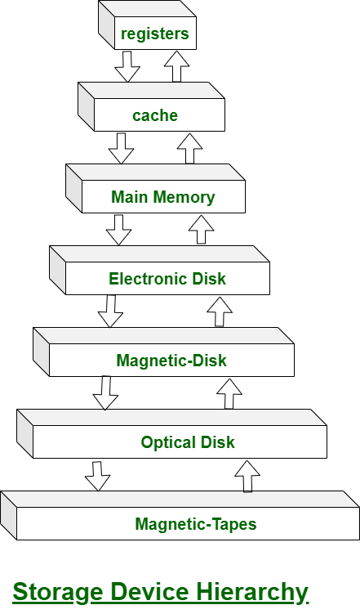

In this hierarchy all the storage devices are arranged according to speed and cost. The higher levels are expensive, but they are fast. As we move down the hierarchy, the cost per bit generally decreases, where as the access time generally increases.

The storage systems above the Electronic disk are Volatile, where as those below are Non-Volatile.

* Magnetic disks provide bulk of secondary storage of modern computers
  + Drives rotate at 60 to 250 times per second
  + Transfer rate is rate at which data flow between drive and computer
  + Positioning time (random-access time) is time to move disk arm to desired cylinder (seek time) and time for desired sector to rotate under the disk head (rotational latency)
  + Head crash results from disk head making contact with the disk surface
    - That’s bad
* Disks can be removable
* Drive attached to computer via I/O bus
  + Busses vary, including EIDE, ATA, SATA, USB, Fibre Channel, SCSI, SAS, Firewire
  + Host controller in computer uses bus to talk to disk controller built into drive or storage array
  + 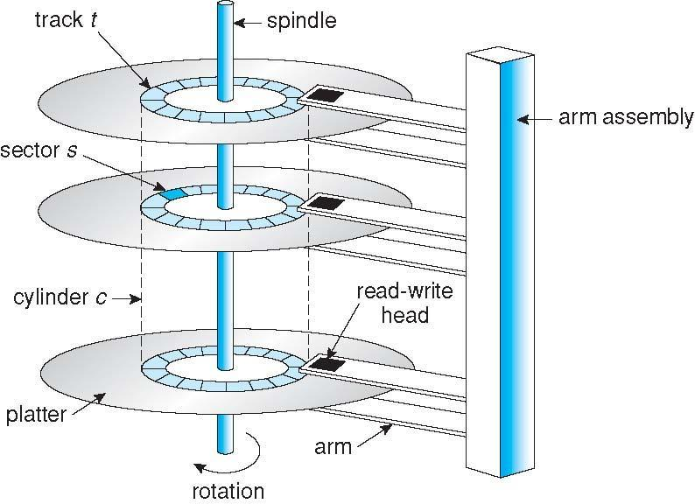**Moving-head Disk Mechanism**

**Disk Structure**

* Disk drives are addressed as **large 1-dimensional arrays of logical blocks**, where the logical block is the smallest unit of transfer
* The 1-dimensional array of logical blocks is mapped into the sectors of the disk sequentially
  + Sector 0 is the first sector of the first track on the outermost cylinder
  + Mapping proceeds in order through that track, then the rest of the tracks in that cylinder, and then through the rest of the cylinders from outermost to innermost
  + Logical to physical address should be easy
    - Except for bad sectors
    - Non-constant # of sectors per track via constant angular velocity

**Disk Scheduling**

* The operating system is responsible for using hardware efficiently — for the disk drives, this means having a fast access time and disk bandwidth
* Minimize seek time
* Seek time ≈ seek distance
* Disk bandwidth is the total number of bytes transferred, divided by the total time between the first request for service and the completion of the last transfer

**Disk Scheduling Algorithm**

* **Seek Time:Seek time is the time taken to locate the disk arm to a specified track where the data is to be read or write. So the disk scheduling algorithm that gives minimum average seek time is better.**
* **Rotational Latency: Rotational Latency is the time taken by the desired sector of disk to rotate into a position so that it can access the read/write heads. So the disk scheduling algorithm that gives minimum rotational latency is better.**
* **Transfer Time: Transfer time is the time to transfer the data. It depends on the rotating speed of the disk and number of bytes to be transferred.**
* **Disk Access Time: Disk Access Time is:**

**Disk Access Time = Seek Time + Rotational Latency + Transfer Time**

* We illustrate scheduling algorithms with a request queue (0-199)

98, 183, 37, 122, 14, 124, 65, 67

Head pointer 53

1. FCFS

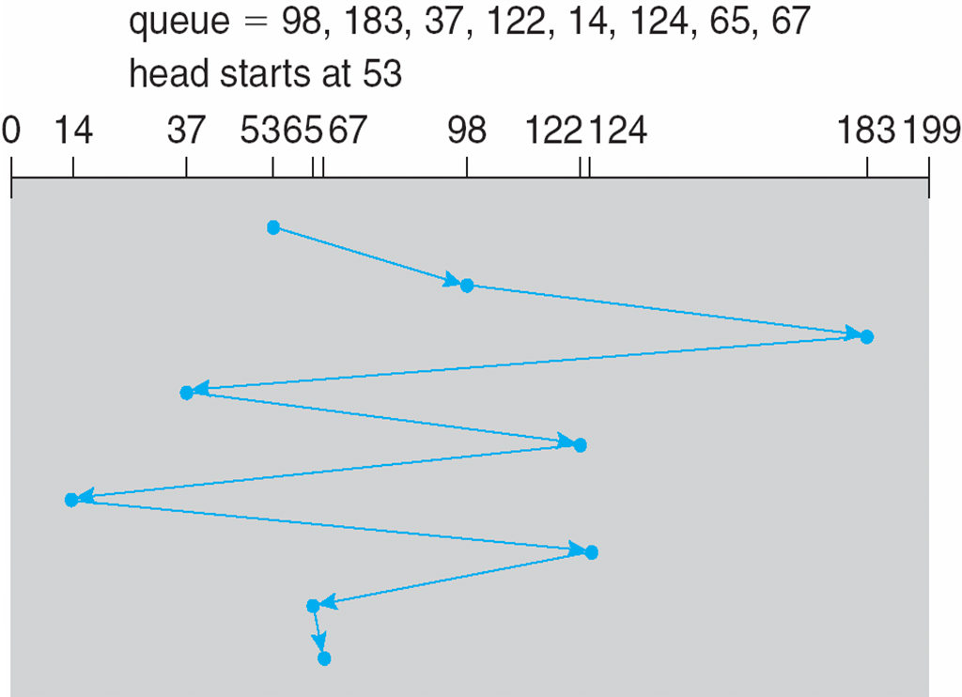**total head movement**  **= (98-53)+(183-98)+(183-37)+(122-37)+(122-14)+(124-14)+(124-65)+(67-65)**

**45+85+146+85+108++59+2+110=640**

**Advantages:**

* Every request gets a fair chance
* No indefinite postponement

**Disadvantages:**

* Does not try to optimize seek time
* May not provide the best possible service
* **Intractive example:** [**https://www.cs.usask.ca/faculty/makaroff/cgi-bin/disk_sched.pl**](https://www.cs.usask.ca/faculty/makaroff/cgi-bin/disk_sched.pl)

**SSTF(***Shortest Seek Time First* **)**

* Shortest Seek Time First selects the request with the minimum seek time from the current head position
* SSTF scheduling is a form of SJF scheduling; may cause starvation of some requests
* Illustration shows total head movement of 236 cylinders

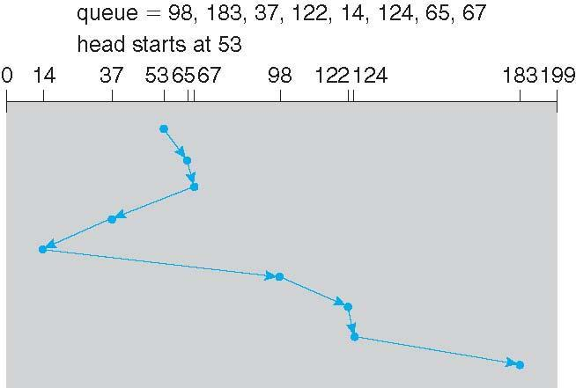

**Advantages:**

* Average Response Time decreases
* Throughput increases

**Disadvantages:**

* Overhead to calculate seek time in advance
* Can cause Starvation for a request if it has higher seek time as compared to incoming requests
* High variance of response time as SSTF favours only some requests

**SCAN**

* The disk arm starts at one end of the disk, and moves toward the other end, servicing requests until it gets to the other end of the disk, where the head movement is reversed and servicing continues.
* Sometimes called the ***elevator algorithm*.**
* Illustration shows total head movement of 208 cylinders.

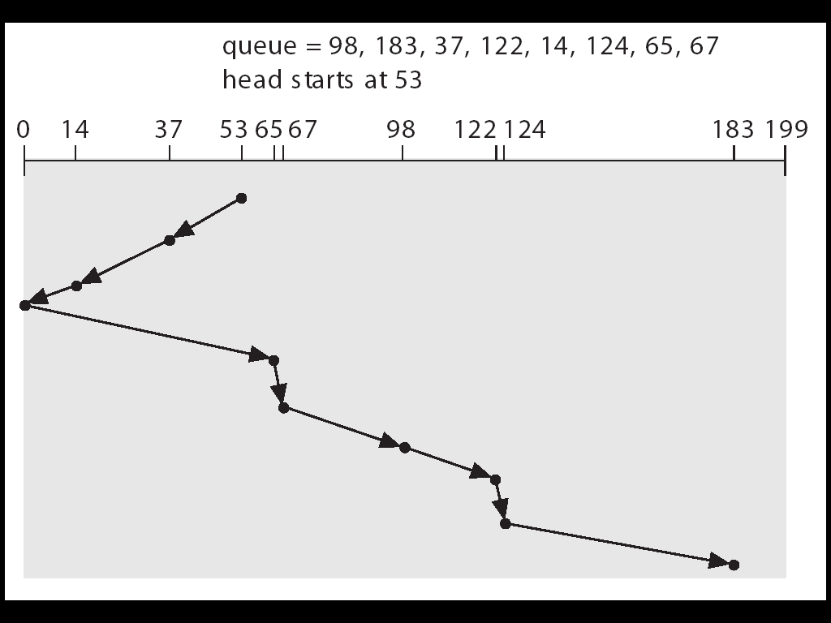

**Advantages:**

* High throughput
* Low variance of response time
* Average response time

**Disadvantages:**

* Long waiting time for requests for locations just visited by disk arm

**C-SCAN**

* Provides a more uniform wait time than SCAN.
* The head moves from one end of the disk to the other. servicing requests as it goes. When it reaches the other end, however, it immediately returns to the beginning of the disk, without servicing any requests on the return trip.
* Treats the cylinders as a circular list that wraps around from the last cylinder to the first one.

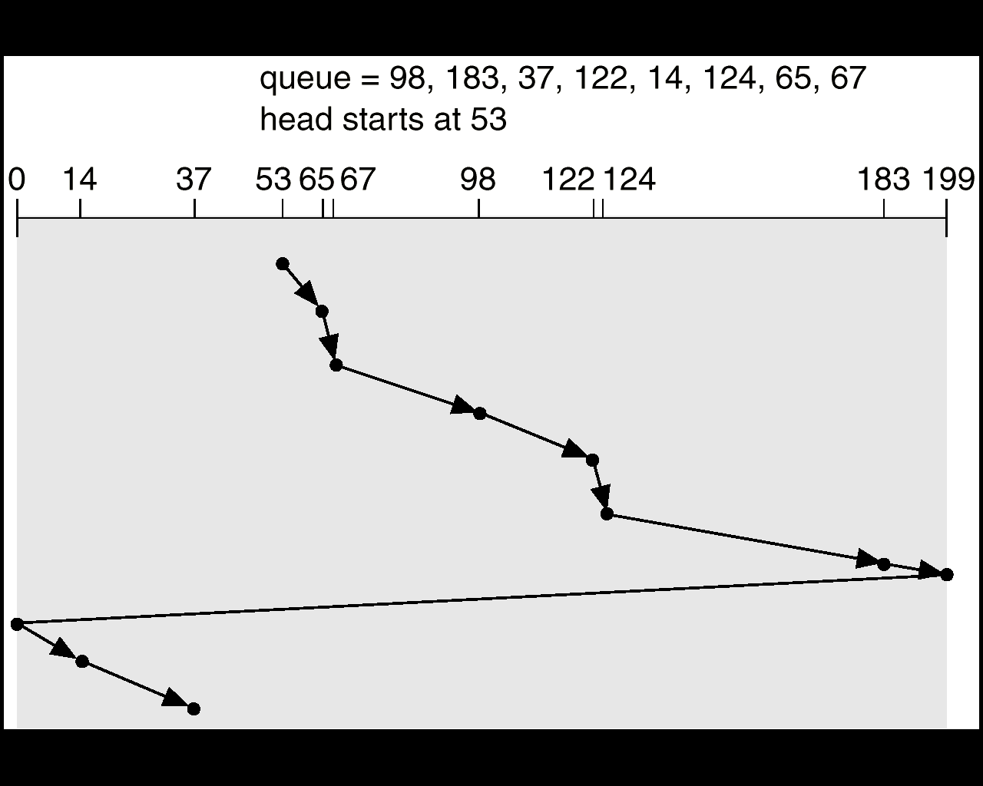

Advantages:

* Provides more uniform wait time compared to SCAN

**C-LOOK**

* Version of C-SCAN
* Arm only goes as far as the last request in each direction, then reverses direction immediately, without first going all the way to the end of the disk.

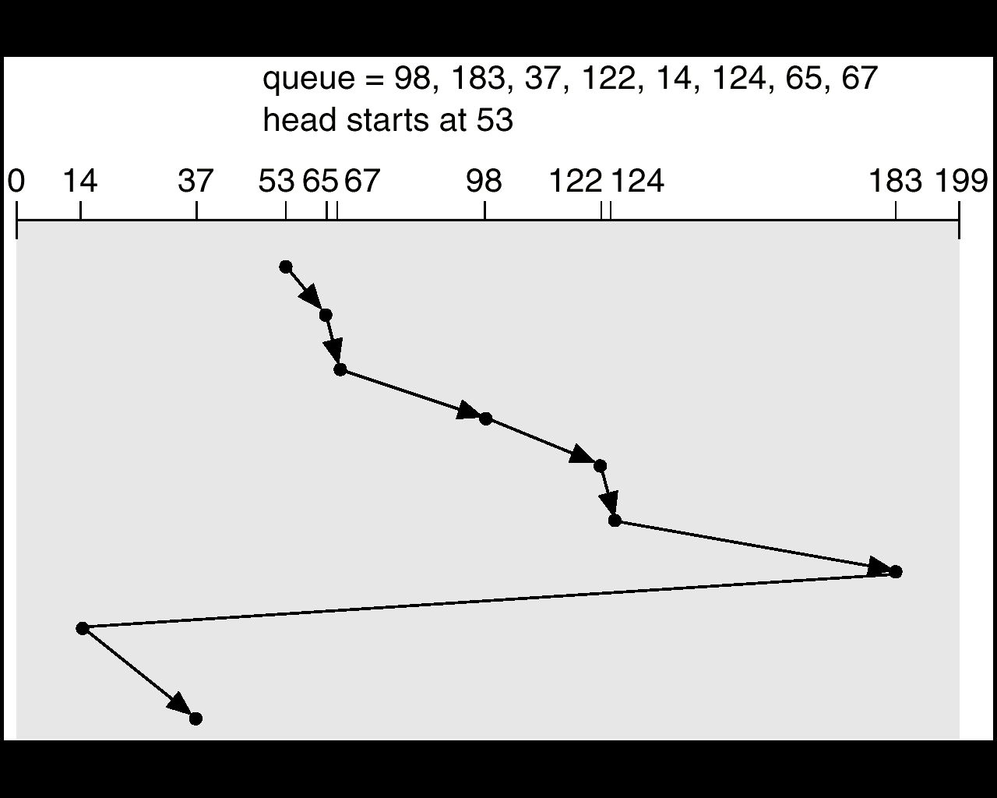



**Selecting a Disk-Scheduling Algorithm**

* SSTF is common and has a natural appeal
* SCAN and C-SCAN perform better for systems that place a heavy load on the disk.
* Performance depends on the number and types of requests.
* Requests for disk service can be influenced by the file-allocation method.
* The disk-scheduling algorithm should be written as a separate module of the operating system, allowing it to be replaced with a different algorithm if necessary.
* Either SSTF or LOOK is a reasonable choice for the default algorithm.

Example 82,170,43,140,24,16,190)

And current position of Read/Write head is : 50

**FCFS**